The Islamia University of Bahawalpur
Department of Information Technology
Faculty of Computing



Software Requirement Specification (SRS)
for

Smart Attendance With QR Codes

Version 1.0

By
Zeeshan Ahmad Virk
S23BINFT1M01115
Session Spring 2023 – 2027
Supervisor
Ms Sara Fareed
Bachelor of Science in Information Technology

Revision History

Name | Date | Reason for changes | Version

Document Approval
The following Software Requirements Specification has been accepted and approved by the following:
Signature | Printed Name | Title | Date

Application Evaluation History

Comments (by committee)  *include the ones given at scope time both in doc and presentation | Action Taken

Supervised by
Ms Sara Fareed

Signature______ _____

Table of Contents

1. Introduction 1
1.1 Purpose 1
1.2 Scope 1
1.3 Definitions, Acronyms, and Abbreviations. 1
1.4 References 1
1.5 Overview 1
2. The Overall Description 2
2.1 Product Perspective 2
2.1.1 Operations 2
2.1.2 Site Adaptation Requirements 3
2.2 Product Functions 3
2.3 User Characteristics 3
2.4 General Constraints 4
2.5 Assumptions and Dependencies 4
3. Specific Requirements 4
3.1 External Interface Requirements 5
3.1.1 System Interfaces 5
3.1.2 Interfaces 5
3.1.3 Hardware Interfaces 5
3.1.4 Software Interfaces 5
3.1.5 Communications Interfaces 6
3.2 Functional Requirements 6
3.2.1 <Functional Requirement or Feature #1> 6
3.2.2 <Functional Requirement or Feature #2> 7
3.3 Use Cases 7
3.3.1 Use Case #1 7
3.3.2 Use Case #2 7
3.4 Classes / Objects 7
3.4.1 <Class / Object #1> 7
3.4.2 <Class / Object #2> 7
3.5 Non-Functional Requirements 7
3.5.1 Performance 8
3.5.2 Reliability 8
3.5.3 Availability 8
3.5.4 Security 8
3.5.5 Maintainability 8
3.5.6 Portability 8
3.6 Inverse Requirements 8
3.7 Logical Database Requirements 8
3.8 Design Constraints 8
3.8.1 Standards Compliance 8
4. Analysis Models 9
4.1 Sequence Diagrams 9
4.2 Data Flow Diagrams (DFD) 9
4.3 State-Transition Diagrams (STD) 9
5. Supporting Information 9
Appendix A – Background Research on: 9
Appendix B – Data Dictionary 9

Introduction
This is web application based on PHP. That helps in taking Attendance of students of Schools, Colleges and offices with much ease. It uses QR CODE for making attendance at a great pace with no human error. It creates a unique QR CODE for all users for taking fast attendance. Takes all the attendance data from Database. An Admin can view, Edit and also generate report easily.
This software provides a safe server for login which does not allow anyone else other than the management and staff to view the attendance. So the accuracy is maintained and paper work is reduced to the fullest by storing all data in the server of the software hence the attendance system enhances efficiency, saves time, increases reliability and accuracy in attendance.

Purpose
Our purpose in this project is to develop a system that could capture attendance efficiently, accurately, and automatically by means of QR codes. This aims to eliminate errors that can occur with manual methods of capturing attendance, save paper and reduce processing time to facilitate the administrator, teachers and staff of educational institutions to be more productive.

1.2 Scope

We are developing a web based solution for easy attendance tracking and management using QR (Quick Response) Codes built using PHP and MySQL. Easy to use interface, allows administrator to view, edit and monitor attendance details. It can be extended with features such as Mobile App for attendance tracking, SMS/Email notifications for administrators, attendance reports and much more. This saves a lot of time for administrators and also makes a organization’s management systems more accurate and efficient.

1.4 References
No. | Document Title | Report No. / Version | Date | Publishing Organization | Source
1 | IEEE Standard for Software Requirements Specification | IEEE 830-1998 | 1998 | IEEE | https://standards.ieee.org
2 | ISO/IEC/IEEE Systems and Software Engineering — Life Cycle Processes | ISO/IEC/IEEE 12207 | 2017 | ISO / IEEE | https://www.iso.org
3 | PHP Official Documentation | PHP 8.x | Latest | PHP Group | https://www.php.net/docs.php
4 | MySQL Database Documentation | MySQL 8.x | Latest | Oracle Corporation | https://dev.mysql.com/doc/
5 | HTML Living Standard | HTML5 | Latest | WHATWG | https://html.spec.whatwg.org
6 | CSS Specifications | CSS3 | Latest | W3C | https://www.w3.org/Style/CSS/
7 | QR Code Technology Documentation | QR Code Standard | Latest | ISO / Denso Wave | https://www.qrcode.com/en/
This section provides a complete list of documents and resources referenced in the Software Requirements Specification (SRS) for the Smart Attendances With QR Codes. These documents offer standards, technical background, and supporting information relevant to understanding the requirements of the system. All references are publicly available and can be obtained from the sources specified below.

1.5 Overview
The system's design is a web-based client-server solution utilizing PHP and a database with a web-based front end and back end. This configuration allows for easy scalability and maintainability using a split front end / back end approach. The system incorporates both QR code generation and QR code reading functions and seamlessly interfaces all system parts together. This configuration allows for the robust, flexible, and reliable handling of attendance data.
This module for school, college or university management is completely developed with PHP script and configured to fetch and update data through internet to validate school generated QR codes for tracking students attendance and processing the attendance data for generation of reports. The system is designed to handle any number of users at same time without compromising on the robustness and stability of system. It also manages to process data accurately.

2. The Overall Description
We have made as much as possible simple and user-friendly for administrators and users alike. The online interface runs from your web browser - no software installation required. The layout uses clear menus, buttons and links.
Login Page, to prevent any unwanted usage of the system by restricting unauthorized users to login to the system. Dashboard contains summary of user’s attendance records, latest activities updates and few quick actions that can be performed. This dashboard is completely responsive and can be accessed from desktop, tablet as well as mobile version

2.1 Product Perspective
The Attendance Management module comes with a module-wide dashboard that visually displays various summary statistics related to the attendance and attendance tracking activities. This includes summary of attendance records for employees as well as other related statistics such as records marked as present or absent, details of last login, tracking attempts, timed out attempts and number of records approved or rejected. The module dashboard also displays summary statistics for employee attendance and login activities such as details of last login, tracking attempts, timed out attempts, approved and rejected attendance records to facilitate quicker administrative decision making.

2.2 Product Functions

User Management Module
The Users module contains all system participants including students, employees and administrators. In this module users can be added, updated, deleted, with each user receiving their own unique QR code. This module also manages users’ roles, permissions to work with different system modules and other settings that allow users to have different access rights to work with various functions and ensure overall system control.

QR Code Generation Module
This module will generate unique QR Codes for each registered user. Those generated QR codes will be used to mark attendance in a faster and accurate manner. These generated QR Codes will be secure and will not be easily duplicated. This will help to make attendance marking process faster and reduces manual involvement and errors.

Attendance Management Module
Attendance tracker records attendance information by scanning of QR codes. Records all scanned QR codes along with date, time and user information. All records can be viewed and edited by the admin for accurate attendance tracking and recording. Helps in recording and tracking attendance in real time and accurately and provides efficient management of attendance.

Authentication and Authorization Module
Login system to securely recognise user. Role based access controls for admin and normal users. Only logged in users with the correct permission can edit attendance or generate reports for data privacy, system security and against unauthorised access.

Database Management Module
This module handles the functionality for storing, managing and retrieving the systems data (system, users and attendance). This includes maintaining data integrity and usability. The database module can handle large amounts of data and is also able to support creating backups and performing a recovery in the event of data loss.

Dashboard Module
The Attendance Management module comes with a module-wide dashboard that visually displays various summary statistics related to the attendance and attendance tracking activities. This includes summary of attendance records for employees as well as other related statistics such as records marked as present or absent, details of last login, tracking attempts, timed out attempts and number of records approved or rejected. The module dashboard also displays summary statistics for employee attendance and login activities such as details of last login, tracking attempts, timed out attempts, approved and rejected attendance records to facilitate quicker administrative decision making.

Search and Filtering Module
The software includes a fully searchable attendance module to enable you to search for specific attendance records using a variety of search filters. By searching by date, name or attendance status, the attendance module makes administration much more efficient by saving time when searching for individual records as well as allowing administrators to easily analyse attendance records for reporting and monitoring purposes.

2.3 User Characteristics
The Users module contains all system participants including students, employees and administrators. In this module users can be added, updated, deleted, with each user receiving their own unique QR code. This module also manages users’ roles, permissions to work with different system modules and other settings that allow users to have different access rights to work with various functions and ensure overall system control.

2.4 General Constraints
QR Code Attendance System has limitations like Stable Internet Connection, Web Browser and Device to attend attendance with Camera Capability to Scan QR Codes. Access is restricted to logged in users only. It is based on PHP and MySQL. System performance may vary on factors like Server Load, Database Size and Network Speed.

2.5 Assumptions and Dependencies
We assume that all users (students/employees and admins) have access to an internet enabled device such as a PC, Laptop, Tablet or Smartphone and a web browser such as Google Chrome, Mozilla Firefox or Microsoft Edge that supports camera capture of QR Codes. We also assume that all users will provide accurate information during their self registration process. We have used PHP as the language to develop the backend of the system and MySQL as the database management system. A suitable web server is also required to run and host the system, in order to store and serve data and perform communication.

3. Specific Requirements

3.1 External Interface Requirements

3.1.1 System Interfaces
No. | External System / Device | Functionality Supported | Interface Description
1 | Web Browser | Provides user access to the attendance system for login, QR scanning, and report viewing | The system supports modern browsers (Chrome, Firefox, Edge, Safari) via HTTPS. All pages are responsive and secure for users and admins.
2 | Camera / QR Scanner Device | Scans QR codes to mark attendance quickly and accurately | The system uses device camera or scanner to read QR codes and send data to the server for validation and attendance marking.
3 | Display / Dashboard Interface | Displays attendance records, user details, and system reports | The system outputs processed attendance data through web-based dashboards using HTML, CSS, and JavaScript visual components.
4 | Database / Data Storage | Stores user information, QR codes, and attendance records | The system interacts with MySQL database using secure SQL queries for storing and retrieving attendance data efficiently.
5 | Web Server / Hosting Environment | Runs PHP scripts and handles system requests | The system requires Apache/Nginx server with PHP and MySQL support to process requests and manage backend operations.
6 | Notification / Messaging System (Optional) | Sends alerts for attendance confirmation or invalid QR scans | The system can integrate email/SMS APIs (SMTP, Twilio) to send real-time notifications to users and administrators.

3.1.2 Interfaces
The system has a simple, clean & User Friendly interface both for Admins & Users. The system has an easy to use interface with obvious navigation to Mark Attendance and View Reports etc. It’s super fast and supports QR Code Scanning using smartphone cameras. The system is designed to minimize the users’ efforts & makes it accessible for students, faculties & admin.

3.1.3 Hardware Interfaces
QR Code Attendance System requires basic hardware and infrastructure. These would include a PC, Laptop or Smartphones that are capable of taking QR Code Scans via integrated camera. Stable Internet Infrastructure for connection to remote server and necessary hardware to host server and database. Computer is also equipped with usual hardware such as keyboard, mouse and monitors which are used for displaying attendance information and administration panel.

3.1.4 Software Interfaces
No. | Name | Mnemonic | Specification / Doc No. | Version | Source
1 | PHP | PHP | PHP Language Reference | 8.x+ | PHP Group (https://www.php.net)
2 | MySQL | SQL | MySQL Reference Manual | 8.x | Oracle Corporation (https://dev.mysql.com/doc/)
3 | HTML / CSS / JavaScript | H/C/J | W3C Web Standards Specifications | Latest | W3C (https://www.w3.org)
4 | QR Code Library | QR | QR Code Generation/Scanning Library Docs | Latest | QR Code Standards / Open-source libraries (https://www.qrcode.com)
5 | Web Server (Apache/Nginx) | WS | Server Configuration Documentation | Latest | Apache Foundation / Nginx (https://httpd.apache.org)

3.2 Functional Requirements
This section describes specific features of the software project. If desired, some requirements may be specified in the use-case format and listed in the Use Cases Section.
Subsection | Description
3.2.1.1 Introduction | This function allows users (students/employees) and administrators to access the QR Code Attendance System through a web interface. It enables secure login, QR code scanning for attendance marking, and management of attendance records. All interactions are handled reliably through the web-based system.
3.2.1.2 Inputs | User inputs include login credentials, QR code scans, attendance requests, and admin actions such as adding users or generating reports. Inputs are provided through web forms, QR scanners, buttons, or system requests and are validated before processing.
3.2.1.3 Processing | The system validates user input, verifies QR codes, and processes attendance marking using PHP and SQL queries. Attendance data is stored in the database, and reports are generated. Server-side processing ensures accurate, real-time updates and secure handling of all operations.
3.2.1.4 Outputs | The system displays attendance confirmation, dashboards, user lists, and generated reports. Outputs are shown through the web interface and may include alerts for successful login, invalid QR scans, or attendance status updates.
3.2.1.5 Error Handling | Invalid login attempts, incorrect QR codes, missing data, or server/database errors generate error messages. These errors are displayed to users and logged for administrator review to ensure system reliability and troubleshooting.

User Management Module
Subsection | Description
3.2.1.1 Introduction | This module manages all users of the system including students, employees, and administrators. It handles registration, login, profile management, and role assignment for secure system access.
3.2.1.2 Inputs | User details such as name, email, password, role selection, and profile update information entered through web forms.
3.2.1.3 Processing | System validates user input, encrypts passwords, stores user data in the database, and manages authentication and authorization using PHP.
3.2.1.4 Outputs | User account confirmation, login success messages, profile details, and access permissions displayed on the dashboard.
3.2.1.5 Error Handling | Invalid credentials, duplicate email, or missing fields generate error messages and are logged for admin review.

QR Code Management Module
Subsection | Description
3.2.1.1 Introduction | This module manages all users of the system including students, employees, and administrators. It handles registration, login, profile management, and role assignment for secure system access.
3.2.1.2 Inputs | User details such as name, email, password, role selection, and profile update information entered through web forms.
3.2.1.3 Processing | System validates user input, encrypts passwords, stores user data in the database, and manages authentication and authorization using PHP.
3.2.1.4 Outputs | User account confirmation, login success messages, profile details, and access permissions displayed on the dashboard.
3.2.1.5 Error Handling | Invalid credentials, duplicate email, or missing fields generate error messages and are logged for admin review.

Attendances Management
Subsection | Description
3.2.3.1 Introduction | This module records and manages attendance when QR codes are scanned by users.
3.2.3.2 Inputs | QR scan data, user ID, date, and time of attendance marking.
3.2.3.3 Processing | System validates QR code, checks user identity, and stores attendance records in the database.
3.2.3.4 Outputs | Attendance status (Present, Late, Absent) displayed on dashboard and reports.
3.2.3.5 Error Handling | Invalid QR code or duplicate scan entries generate error messages and prevent incorrect attendance marking.

Authentication & Security
Subsection | Description
3.2.4.1 Introduction | Ensures secure login and protects system data from unauthorized access.
3.2.4.2 Inputs | Username, password, login requests, and session tokens.
3.2.4.3 Processing | System verifies credentials, encrypts passwords, and manages session-based authentication using PHP.
3.2.4.4 Outputs | Login success/failure messages and secure session access to dashboard.
3.2.4.5 Error Handling | Incorrect login attempts or unauthorized access are blocked and logged for security monitoring.

3.3 Use Cases
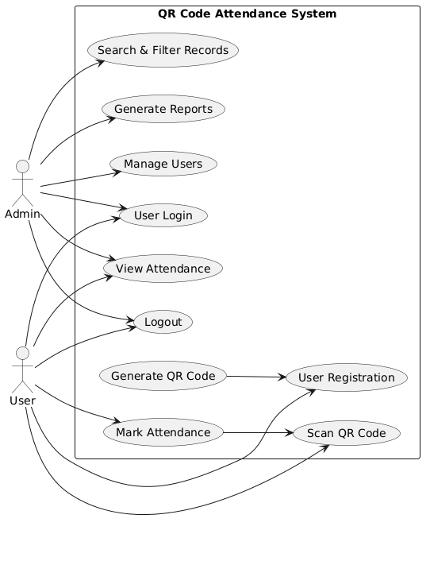
Use Case Diagram for the QR Code Attendance System, detailing the functional requirements and administrative controls for both Admin and User roles.

3.4 Classes / Objects
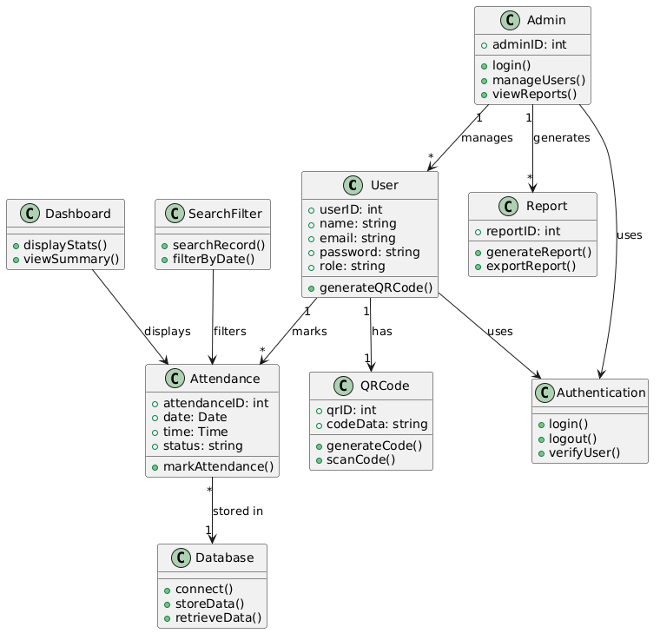

Class Diagram of the QR Code Attendance System, illustrating the object-oriented structure, class attributes, methods, and the relationships between system modules.

3.5 Non-Functional Requirements

3.5 Non-Functional Requirements

3.5.1 Performance
Transactions, QR scans etc should time out as quickly as possible and system should support multiple users at the same time processing attendance and report(s) in real time while loading on the dashboard being instantaneous.

3.5.2 Reliability
The system is designed to provide around the clock attendance tracking with the least amount of downtime possible. The system automatically recovers from faults and when under heavy utilization, it operates efficiently without any loss of attendance data or user records.

3.5.3 Usability
Our system for tracking student, employee, and faculty attendance is simple to understand and use by students, employees, administrators as well as faculty. Quick QR code scans, attendance marks and easy to view reports - no specialized training needed.

3.5.4 Security
Veggo’s attendance records system is safeguarded by username and password protected log-in, data authentication and encrypted connection to protect your attendance records from any unauthorised alterations or viewing. Access can be limited to relevant users.

3.5.5 Maintainability
With our attendance software system, you can update and maintain records while your attendance data will be preserved and unaffected by the updates. Admin can modify, update and include features without effecting the system to operate.

3.5.6 Portability
The system can be configured to run on most web servers which support PHP/MySQL and it is browser compatible with most modern browsers.

3.7 Logical Database Requirements
Entity | Description | Key Attributes | Frequency of Use | Access Capabilities
User | Stores information about registered users such as students, employees, and admins in the attendance system. | userID, name, email, password, role, QR_code, registrationDate | High (login, QR scanning, attendance marking) | Read/Write by admin; Read by user for own profile
QR Code | Stores unique QR codes assigned to each user for attendance marking. | qrID, userID, qrCodeData, generatedDate | High (used during every attendance scan) | Read/Write by system; Read by admin
Attendance | Stores attendance records generated when QR codes are scanned. | attendanceID, userID, date, time, status | Very High (daily attendance marking) | Read/Write by system; Read by admin and user
Admin | Stores administrator details who manage the system and users. | adminID, name, email, password, role | Medium (system management activities) | Read/Write by admin only
Reports | Stores generated attendance reports for analysis and record keeping. | reportID, generatedDate, reportType, content | Medium (report generation and review) | Read/Write by admin; Read by authorized users
System Logs | Stores system activity logs including login attempts and QR scan actions. | logID, userID, action, timestamp, status | Medium/Low (for monitoring and auditing) | Read/Write by system; Read by admin

3.7 Design Constraints

2.1 Architectural Design
The system's design is a web-based client-server solution utilizing PHP and a database with a web-based front end and back end. This configuration allows for easy scalability and maintainability using a split front end / back end approach. The system incorporates both QR code generation and QR code reading functions and seamlessly interfaces all system parts together. This configuration allows for the robust, flexible, and reliable handling of attendance data.

2.1.1 User Interface (UI) and User Experience (UX)
The system has a simple, clean & User Friendly interface both for Admins & Users. The system has an easy to use interface with obvious navigation to Mark Attendance and View Reports etc. It’s super fast and supports QR Code Scanning using smartphone cameras. The system is designed to minimize the users’ efforts & makes it accessible for students, faculties & admin.

4. Analysis Models
Several analysis models have been developed to provide a clear understanding of the functional and non-functional requirements of the Smart Attendances with QR Codes system and to support traceability throughout the SRS. These models include use case diagrams, class diagrams, sequence diagrams, entity-relationship (ER) diagrams, and state transition diagrams.
- The use case diagram identifies interactions between external actors, such as users, administrators, and external services (e.g., email, analytics APIs), with the system, providing a visual representation of all primary functionalities, including service browsing, campaign management, user management, reporting, notifications, and system configuration.
- The class diagram captures the static structure of the system, showing major classes such as SystemController, User, Campaign, ServiceManager, Analytics, NotificationManager, and Logger, along with their relationships. This allows developers to trace each class to the functional requirements it supports.
- Sequence diagrams illustrate the flow of operations for critical functions, such as creating campaigns, updating analytics, sending notifications, or generating reports, showing the order of interactions between classes and external entities.
- The ER diagram represents the logical data model, identifying data entities, attributes, and relationships for users, campaigns, services, metrics, and alerts, providing a foundation for database design and ensuring traceability to data storage and retrieval requirements.
- State transition diagrams model the dynamic behavior of key system components, such as campaign states (draft, active, completed) and notification sequences, ensuring all possible system states and transitions are accounted for in functional requirements.
Together, these analysis models form a comprehensive framework that supports the derivation, validation, and traceability of all requirements documented in this SRS, providing developers and stakeholders with a clear understanding of system behavior, interactions, and expected operations.

4.1 Sequence Diagrams
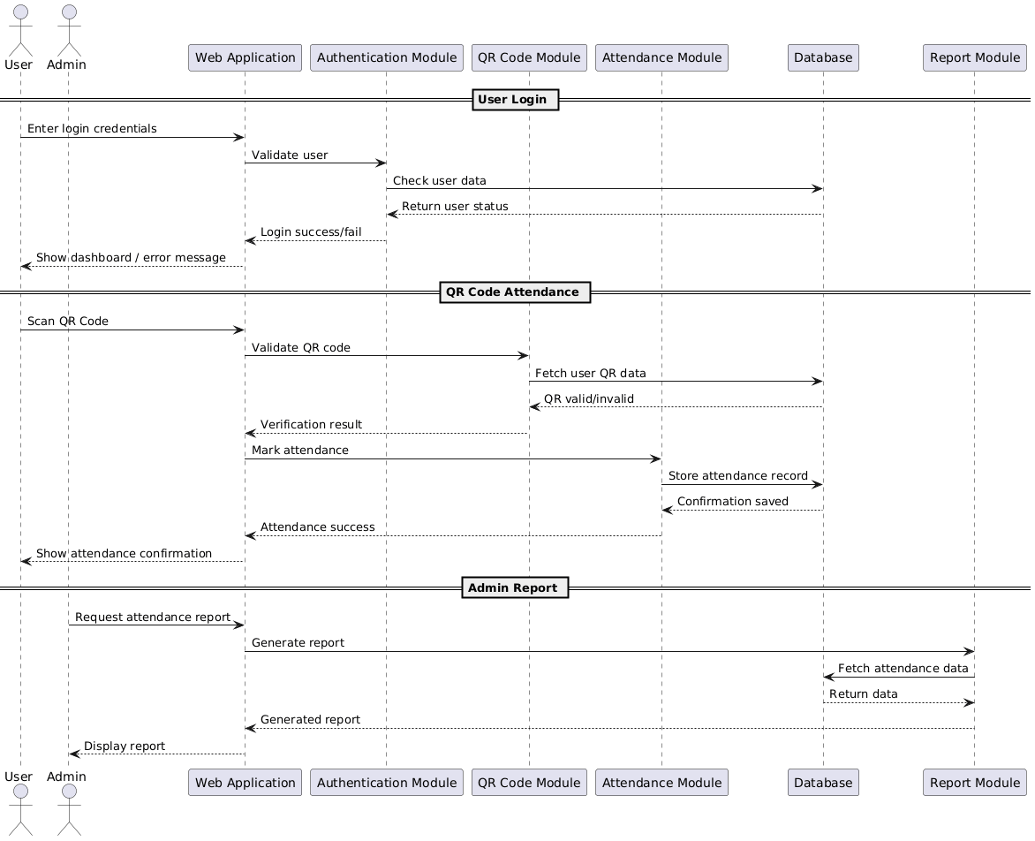
Sequence Diagram of the QR Code Attendance System, highlighting the interaction flow between actors and backend modules for login, attendance marking, and report generation.

4.2 Data Flow Diagrams (DFD)

Level 0
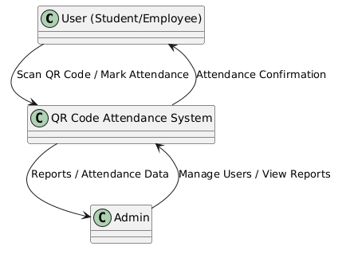
Data Flow Diagram (Level 0) of the QR Code Attendance System, illustrating the high-level data exchange between the system and the external entities (User and Admin).

5. Supporting Information
QR Code Attendance System is an innovative and powerful web based software for managing, tracking and monitoring the attendance of students / employees in Schools, Colleges, Offices and similar institutions. Users (students / employees) can mark their attendance by scanning the designated QR Codes printed / displayed, whereas administrators can add / manage users, view the attendance details and have the option to generate detailed reports at any time. System stores all the details of users, their QR Codes, attendance history etc in a well organized database and can also send optional notifications to the users about their attendance marked, invalid scan, system update etc.
The developed system has been designed to be user friendly, reliable and maintainable. Any ordinary user with minimal training should be able to operate the system by simply scanning a QR code to access various user friendly interactive graphical dashboards that display relevant attendance data.

